**Customer journey map**

|  |  |
| --- | --- |
| Date | 14 APRIL 2025 |
| Team ID | SWTID1742640402 |
| Project Name | MyRide |
| Maximum Marks | 4 Marks |

**Passenger Journey**

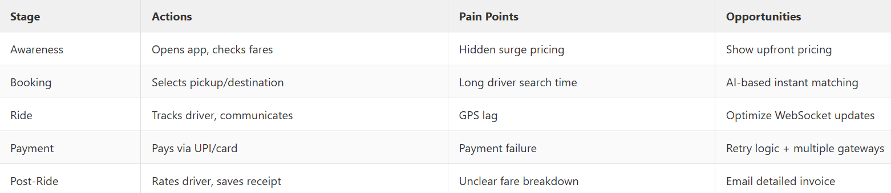

**Driver Journey**

